Use case name: SelectPriceRange

Primary Actor: Customer  
  
Normal flow of events:

1. The customer enters Teknosa website.
2. The customer searches “Telefon” with using search bar.
3. Customer selects price range checkbox.
4. Website shows products that have price between selected range.

Alternate/Exceptional flow:

3A1: Customer does not select any checkbox.

* Website shows all of the products without any filtering.

4E1: Website shows products which they are not in the selected price range.

* Use case ends.



Use case name: SelectRateRange

Primary Actor: Customer  
  
Normal flow of events:

1. The customer enters Teknosa website.
2. The customer searches product with using search bar.
3. Customer selects rate range checkbox.
4. Website shows products that have rate between selected range.

Alternate/Exceptional flow:

3A1: Customer does not select any checkbox.

* Website shows all of the products without any filtering.

4E1: Website shows products which they are not in the selected price range.

* Use case ends.



Use case name: SelectDisplayOrder

Primary Actor: Customer  
Normal flow of events:

1. The customer enters Teknosa website.
2. The customer searches product with using search bar.
3. Customer selects display ascending order by using buttons in website.
4. Website display products with selected order.

Alternate/Exceptional flow:

3A1: Customer selects descending order.

* Website show all of the products with descending order

3A2: Customer does not select any display order.

* Website shows all of the products without any filtering.

4E1: Website shows products without selected order.

* Use case ends.



Boundary Value Analyses of Changing Quantity of Product

Assume that q denotes the used quantity.

Every product has max quantity value and that defined as attribute of product.

maxQuantityValue denotes the max quantity value of certain product.



Boundary Value Analyses of E-mail



Decision Table for Password



**Use case name:** AddToList  
**Primary Actor:** Customer

**Normal flow of events:**

1. The customer enters the Teknosa website.
2. The customer navigates to a product page.
3. The customer clicks the "Add to List" button.
4. The customer selects an existing list or creates a new list.
5. The customer confirms the action.

**Alternate/Exceptional flow:**

5E1: The product is not added to the list.

* The use case ends.

|  |  |  |  |
| --- | --- | --- | --- |
| **Scenario** | **Existing List** | **New List** | **Expected Result** |
| Add a product to an existing list. | Yes | No | Product added to the list |
| Add a product to a new list. | No | Yes | New list created, product added |

**Use case name:** CreateList  
**Primary Actor:** Customer

**Normal flow of events:**

1. The customer enters the Teknosa website.
2. The customer navigates to their lists on account page.
3. The customer clicks the "Create New List" button.
4. The customer enters the list name.
5. The customer clicks the "Create" button.
6. The website confirms that the list has been created.

**Alternate/Exceptional flow:**  
4A1: The customer does not enter a list name.

* The list will be nameless.

6E1: The list is not created.

* The use case ends.

Equivalence Classes for naming the list//

|  |  |  |  |
| --- | --- | --- | --- |
| Equivalence Classes | | Test Input | Expected Result |
| E1 | 1<=n<49 | "A" | List is created successfully. |
| E2 | n=49 | "A" repeated 49 times | List is created successfully. |
| E3 | n = 50 | "A" repeated 50 times | List is created successfully. |
| E4 | n = 0 | "" | List is created successfully. |
| U1 | 50<n | "A" repeated 51 times | Error message indicating  name exceeds character limit. |

**Use case name:** Deleting Item From an Existing List  
**Primary Actor:** Customer

**Normal flow of events:**

1. The customer enters the Teknosa website.
2. The customer navigates to their lists.
3. The customer selects a list.
4. The customer clicks the "Delete" button next to the item.
5. The website removes the item from the list.

**Alternate/Exceptional flow:**

5E1: The item is not removed from the list.

* The use case ends.

**Use case name:** DeletingAnExistingList  
**Primary Actor:** Customer

**Normal flow of events:**

1. The customer enters the Teknosa website.
2. The customer navigates to their lists.
3. The customer clicks “Edit” button next to the list and then "Delete List " button.
4. The customer clicks "Delete List " button on the edit page.
5. The website removes the list.

**Alternate/Exceptional flow:**

5E1: The list is not deleted.

* The use case ends.

**Use case name:** Invalid Discount Code  
**Primary Actor:** Customer

**Normal flow of events:**

1. The customer enters the Teknosa website.
2. The customer navigates to their cart.
3. The customer enters an invalid discount code.
4. The customer clicks the "Apply" button.
5. The website displays an invalid code message.

**Alternate/Exceptional flow:**

5E1: The website applies the invalid discount code.

* The use case ends.

**Use case name:** MainScreenLoading  
**Primary Actor:** Customer

**Normal flow of events:**

1. The customer enters the Teknosa website.
2. The main screen loads with all necessary components (e.g., banners, product categories, featured products).

**Alternate/Exceptional flow:**  
2E1: The main screen does not load correctly.

* The website displays an error message.

**Use case name:** AddingToCart  
**Primary Actor:** Customer

**Normal flow of events:**

1. The customer enters the Teknosa website.
2. The customer navigates to a product page.
3. The customer clicks the "Add to Cart" button.
4. The website shows a confirmation message that the product has been added to the cart.

**Alternate/Exceptional flow:**  
3A1: The customer clicks the "Add to Cart" button but the product is out of stock.

* The website displays an out-of-stock message.

4E1: The product is not added to the cart.

* The use case ends.

Use case name: ProductSearching

Primary Actor: Customer

Normal flow of events:

1. The customer enters the Teknosa website.

2. The customer types a product name in the search bar.

3. The customer clicks the "Search" button.

4. The website displays the search results with relevant products.

Alternate/Exceptional flow:

4E1: The website does not display relevant products.

• The use case ends.

|  |  |  |  |
| --- | --- | --- | --- |
| Equivalance Classes | | Input | Expected Output |
| E1 | text=0 | empty | No change in screen |
| E2 | 0<text<=89 | 1  88 89 | Website accepts input |
| E3 | 89<text | 90 | Website takes first 89 letters  for input |

**Use case name:** Updating Personal Info  
**Primary Actor:** Customer

**Normal flow of events:**

1. The customer enters the Teknosa website.
2. The customer navigates to their account settings.
3. The customer updates their personal information (e.g., name, email, address).
4. The customer clicks the "Save" button.
5. The website confirms that the information has been updated.

**Alternate/Exceptional flow:**  
3A1: The customer does not enter required information.

* The website prompts the customer to enter the missing information.

5E1: The information is not updated.

* The use case ends.

|  |  |  |  |  |
| --- | --- | --- | --- | --- |
| **Inputs** | **Valid Name** | **Valid Address** | **Valid Phone** | **Expected Output** |
| Missing Name | No | Yes | Yes | Prompt to fill name |
| Missing Address | Yes | No | Yes | Prompt to fill address |
| Missing Phone | Yes | Yes | No | Prompt to fill phone |
| Missing Name, Address | No | No | Yes | Prompt to fill name, address |
| Missing Name, Phone | No | Yes | No | Prompt to fill name, phone |
| Missing Address, Phone | Yes | No | No | Prompt to fill address, phone |
| Missing Name, Address, Phone | No | No | No | Prompt to fill name, address, phone |
| Valid Name, Address, Phone | Yes | Yes | Yes | Update successful |

**PriceCheckBot:**

PriceRangeCheck:

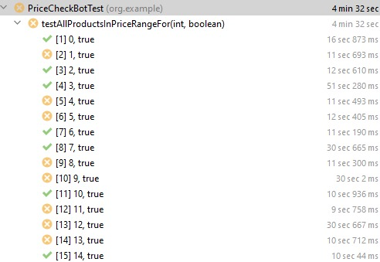

Descending Order Test:



Adscesing Order Test: 

Rate Range Test:

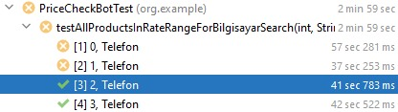

ShoppingCardBot:

Quantity Test Cases:



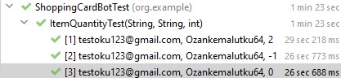



Shopping Card Total Price Check:



JMeter:

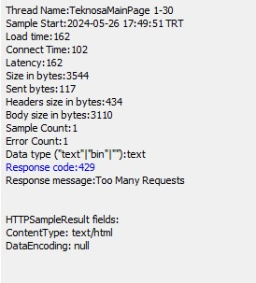

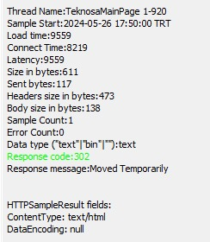



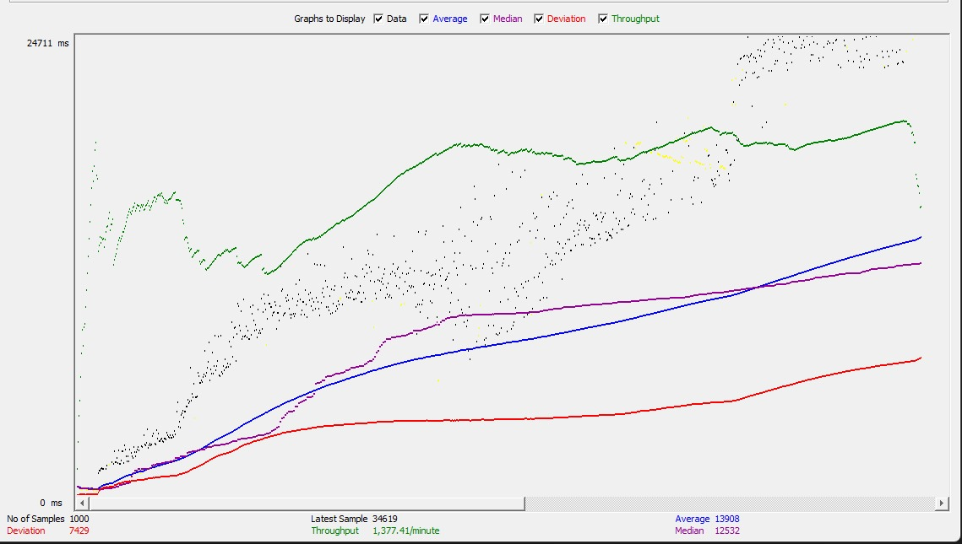

Selenium IDE:

